The 2019 Formula 1 Canadian GP according to Brembo
An in-depth look at the braking systems on the Formula 1 single-seaters at the Circuit Gilles-Villeneuve
From June 7 to 9, Circuit Gilles-Villeneuve will host the 7th race of the 2019 World Formula 1 Championship. Named for the legendary Ferrari driver, this circuit celebrated in the 2017 the 50th anniversary of its first Formula 1 Canadian GP. The first ten editions were held however at Mosport Park (8) and Mont-Tremblant (2). ​
The track is located on the Isle of Notre Dame, an artificial island built in 1965 on the Saint Lawrence River as the Montreal underground was being constructed.​

Characterized by alternating straightaways, chicanes and hairpin turns, this track is without a doubt the toughest test bench for the braking systems on the single-seaters, which usually show up here with a low aerodynamic load. ​
The braking points, all hard and very close together, cause soaring operating temperatures of the discs and pads, which don't have enough time to cool down on the straight stretches. ​
Another problem for the braking systems is the tailwind on the two main straightaways: when it pushes from behind, the straight line speed is increased, putting the brakes to an even more rigorous test. ​
According to Brembo technicians, who classified the 21 tracks in the World Championship, Circuit Gilles-Villeneuve falls into the category of highly demanding circuits for the brakes. On a scale of 1 to 5, it earned a 5 on the difficulty index, a value also obtained by Singapore, Mexico City and Yas Marina tracks.

The demand on the brakes during the GP
As demonstrated by the Monaco GP, the number of braking points is not indicative of how hard the brakes have to work. At Circuit Gilles-Villeneuve, the drivers turn to their brakes only six times per lap, compared to eight times in Melbourne, eleven in Monaco e Baku and fifteen in Singapore. ​
In Canada, the brakes are used for 12.7 seconds every lap, which is equivalent to 18 % of the overall duration of the race. The time spent braking may not be exceptional, but five points on the track are because their peak deceleration reaches at least 5 G and the load applied to the pedal surpasses 125 kg (276 lbs). ​
These figures contribute to the average peak deceleration hitting 4.9 G, the highest of the World Championship. The energy dissipated in braking by each race car during the entire GP is 258 kWh, the same amount as Mexico GP.​
From the starting line to the checkered flag, the Brembo technicians forecast that each driver will exert a total force on the pedal of approximately 57 tons.​
Video: https://youtu.be/Lyq6nhiiaak

The most demanding braking sections
Of the six braking sections on Circuit Gilles-Villeneuve, a good five are considered very demanding on the brakes and one is of medium difficulty.​
The most critical is the brake at turn 13, the chicane that precedes the famous "Wall of Champions" where control going into the turn is essential to avoid launching the car over the kerb: the single-seaters arrive going 338 km/h (210 mph) and brake for 2.09 seconds to reduce their speed to 133 km/h (83 mph). They manage to do this in 122 meters (400 feet). ​
The drivers are required to apply a remarkable amount of force: 139 kg (306 lbs) are applied to the brake pedal and the deceleration measures 5.2 G. Braking on the turn ten is also very difficult, because the speeds drop from 301 km/h (187 mph) to 65 km/h (40 mph) in just 109 meters (358 feet) and 2.64 seconds.
The load on the pedal measures 179 kg (395 lbs) and the deceleration reaches 5.3 G.
In terms of braking distance, turn 1 is also very high: the single-seaters have 113 meters (371 feet) to go from 317 km/h (197 mph) to 149 km/h (93 mph) in just 1.93 seconds.
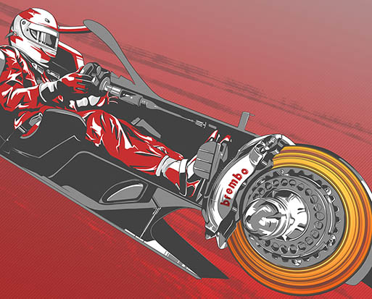

Brembo Performance

Single-seaters with Brembo brakes have won 21 of the 41 Canadian GP races they have participated in, including the last six. The first driver to win three GP races in a row with Brembo calipers was Michael Schumacher with Ferrari, from 2002 to 2004. ​

